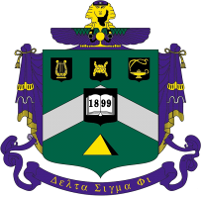
Delta Sigma Phi – CAL POLY / SLO - Epsilon Rho
Alumni Association Newsletter
Issue #9: Summer 2012
Officers: Ray “Mumbles” Calande, W’74; Chris “Yabut” Patterson, W’73; Martin “Beads” Ernst, W’74

Brothers:
We print and surface-mail E-Newsletters to those who don’t use PC’s and to our Assn. members and donors. This E-newsletter is posted, with past issues, on the alumni web site SLOYitbosAlums.com, on the page “Reports”. The site also has a directory, event calendar, reunion info, chapter history, photos, and other chapter and alumni news. Y.I.T.B.O.S., Yabut, Editor

In This Issue:
- At The Chapter – “Landscaping Now Complete”, by Alum. Assn. (page #1)
- Reunion – “April 2012 40th Anniversary - A Gathering Of Brothers”, by Alum. Assn.
  - 1st Annual DSP Charity Golf Tournament Benefits “Aware Awake Alive”
  - DSP Tradition Of The Friday Welcome-Back-BBQ Returns
- Spring ACB Meeting and ACB Gift To Chapter, by Alum. Assn.
- Carnation Ball – “A Special Gathering For The 40^{th”}, by Alum. Assn.
- Venue and Attendees
- Exec Officer Medallion Ceremony
- Recognition of Alumni By National
- Scholarship Presentation
- Chapter History: “The Decision To Build”, by W’70 Greg “Checker” Van Houten
- Chapter President’s Report – “Keeping Our Eye On The Prize”, by Bob “Ace” Veazie, S’76
- Alumni Assn. – “How We Serve Alums And Chapter”, by Chris “Yabut” Patterson, W’73


At The Chapter – “Landscaping Now Complete”
by Alumni Association

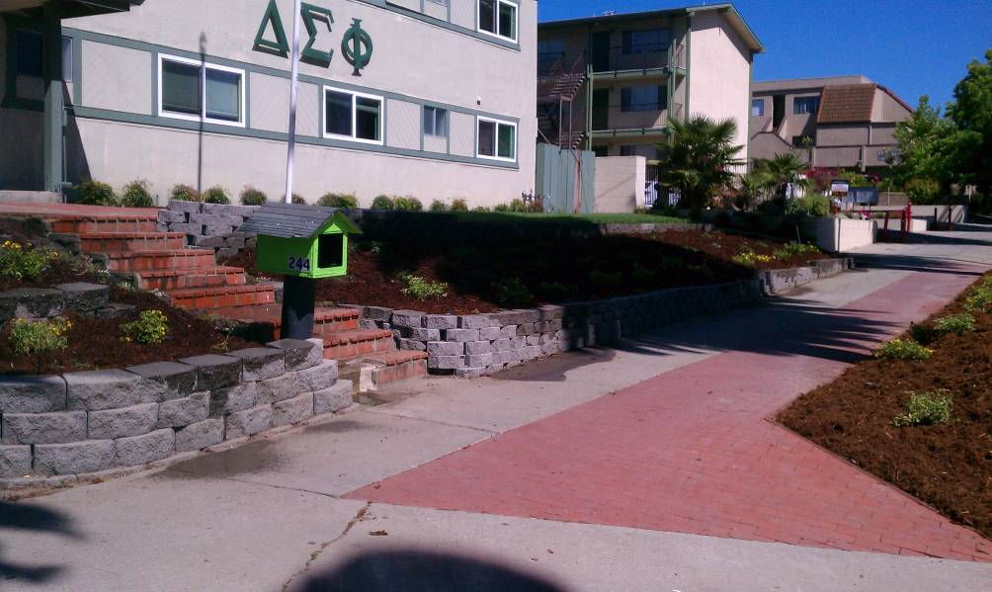
Landscaping efforts at the house, funded by ACB from rents, are nearing completion. In the front, new retaining walls, plantings, more brick walkways, and an irrigation system were added. The back yard has a new lawn.

This project was inspired by past ACB VP-Housing Steve “Twitch” Hawkins, W’75, and heavily supported by landscape architect Dan “Froggie” Veyna, S’74. Thanks also go to W’72 contractor Larry “TA” Everett and his son Trevor. In real-world construction projects, coordination issues often arise. This project was no different! Significant management/labor (alumni/active) issues arose during this project, however all feel a sense of pride in our chapter’s new appearance and the positive message it sends about Delta Sigma Phi!

Editor’s note to “At The Chapter”: Rapidly evolving events between DSP National, campus, ACB, and our chapter resulted in news which alums should be made aware of. As the result of an unauthorized, off-chapter-property, party at an off-campus apartment building DSP rents for live-outs, Epsilon Rho was placed on social probation from late April to July 31st. See our ACB President’s report in this issue for full details, including significant ACB policy changes at the chapter.

Reunion: “April 2012 - 40th Anniversary – A Gathering Of Brothers”
by Alumni Association

The 40th anniversary of moving into the chapter house we built (“New House” / April 1972) was the theme for DSP during Cal Poly’s April 2012 Open House (Poly Royal).

Thursday was no-host golf in Nipomo followed by a BBQ at the Nipomo home of W’72 Larry “TA” Everett and his wife, the lovely Donna. Friday featured a charity golf tournament followed by an alumni/active BBQ in SLO for 200+ brothers, wives, and guests. On Saturday we held a well-attended ACB meeting at the chapter and 250 attended our formal Carnation Ball at the beautiful Camp SLO Officer’s Club that evening.

Charity Golf Tournament:
Under the direction of Jim “Lurch” Larson, W’72, the traditional Friday alumni/active golf tournament was developed into the first annual Delta Sig Charity Golf Tournament. Alumni Mike “Harpo” Roanhaus, S’70, Rich “Puff” Barca, W’72, and Ben “Coco” Parcasio, S’74 helped plan the event. When our active chapter’s membership was asked to nominate a worthy cause, they chose “Aware Awake Alive”. This foundation was created by the parents of Carson Starkey, a Cal Poly undergraduate, after his tragic death in 2008 in SLO from pressured drinking while pledging another fraternity. Our actives said they wished to give this organization “more voice”.

In a letter of appreciation sent our active chapter for selecting this charity, the National Director of the foundation said:

“We at Aware Awake Alive are honored to partner with Delta Sigma Phi and celebrate with current members and alumni as they honor forty years of history. As an alumni of Phi Gamma Delta I can attest to the life long friendships and memories created as a member of Greek life. Carson Starkey died on December 2, 2008 from alcohol poisoning due to coerced drinking during a fraternity hazing ritual. This tragedy affected hundreds of people, including his pledge brothers who were deprived of a lifetime of friendship. As members and alumni of Greek organizations it is our duty to ensure that college years are filled with happy memories and not scared by tragedy. Our young brothers deserve the chance to form the bonds and create the memories we enjoy today. By partnering with Delta Sigma Phi we hope to provide further evidence that Greek organizations are taking the issue of binge drinking seriously and are dedicated to saving lives.”

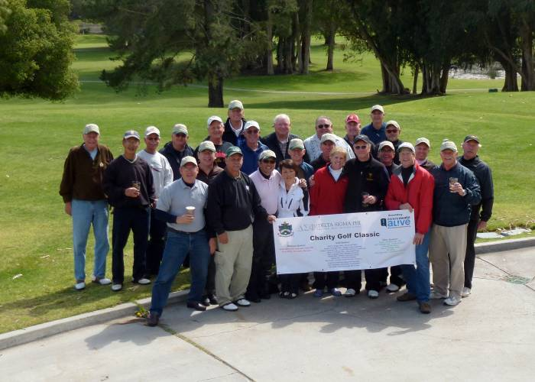
The charity tournament was held at Black Lake Golf Course in Nipomo. Alumni entry fees, tee sponsorships by alumni, and proceeds from silent auctions raised $4,000. National thoughtfully made a $1,000 contribution. On Friday, April 20, 2012, the men of Epsilon Rho were honored to present Carson Starkey’s parents a $5,000 donation to Aware Awake Alive.

This was for you, Carson, and the message and mission carried forward in your name.

Welcome Back BBQ:
With significant support from ACB and the Alumni Association, Friday afternoon saw the return of a great Delta Sig tradition - absent since the late 1980’s – the “Welcome Back BBQ”! In a combined active / alumni effort, over 200 brothers, wives, and guests were treated to a terrific Santa Maria style BBQ at Santa Rosa Park in SLO. Event coordinator Chris “Yabut” Patterson, W’73, sends thanks to all who supported this great event that brought us closer together. Thanks also go to the 1983 Yitbos cooking team of Weeble, Skeeter, and Bullwinkle who tipped their hat to the BBQ tradition of Joel “Mole” Setaro-Pimentel when they were pledges.

Please allow me to change to the “first-person” to finish this story. Mid-morning, standing alone in an empty park in a light rain, I recall thinking I was good-and-screwed and might rightfully be strung-up by the cold, hungry, and possibly wet crowd due that afternoon. Do you recall from your college days as a Delta Sig when one of those wonderful, almost magical, fraternal moments occurred? Few sights ever looked as good as seeing brothers roll in to help. First came men of my era, guys I lived with four decades ago - F’72 Rob “Jitters” Graybehl and his PB Mark “Rollo” Huntley. Then the brother who saved the day arrived! Steve “Weeble” Wagner, F’83, pulled up to the BBQ pits in a pickup truck carrying a mountain of oak firewood, with a wheelbarrow roped to the top, and bringing the knives and expertise necessary to lead the cooking team! To all who helped set up, cook, serve, and clean-up, to W’68 Spanky’s wife (Suzie) and my wife (Carol) who shopped for the raffle prizes, to Exec Commissary Matt “Sharp” Aoto, S’11, and Exec Treasurer Greg “Stoc” Williams, F’09, and a pledge named Cameron, thanks for making this such a memorable event for the brotherhood.

ACB Meeting – And Gift To Chapter:

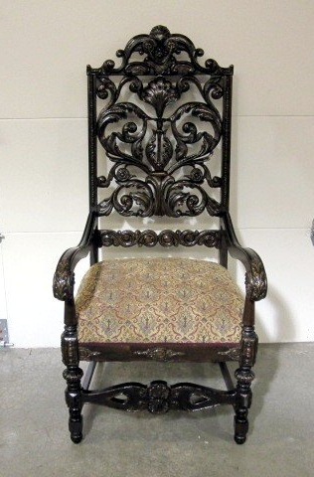
Besides recently providing the chapter funds for new living room furniture, major appliances, and landscaping, ACB presented a very special gift to our chapter at our Spring ACB meeting of April 20th.

Replacing a thrift-store quality, lazy-boy –style President’s chair (with broken feet), ACB gifted a beautiful, antique, replacement President’s Chair. The tradition of this chair is that only the President, alumni, and guests may sit in it during the school year. This tremendous, one-of-a-kind, chair weighs 42 pounds and was discovered in Missouri by the Alumni Association, shipped to SLO, and stored for DSP by past Chapter Supervisor Bill “Fubar” Bradley, F’62. Well done all!

Carnation Ball – A Special Gathering For The 40th
by Alumni Association

Carnation Ball – Venue and Attendees:
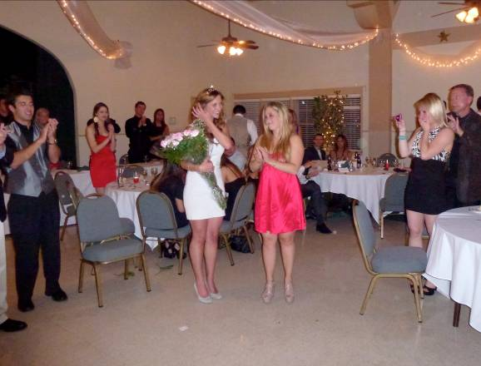
Nearly 250 alumni, wives, actives, dates, and guests attended Carnation Ball at the beautiful Camp SLO Officer’s Club near Cuesta College. National dignitaries present were Executive Director Scott Wiley, Theta Kappa, SUNY Oswego, ’97; Tom Archer, Alpha Mu, University of Virginia, Treasurer, Grand Council; and our own Jim “Lurch” Larson, Epsilon Rho, Cal Poly, W’72, Grand Council. Many past chapter Presidents, past Chapter Supervisors, and past Dream Girls also attended. The photo at the right is of Dream Girl presentation.

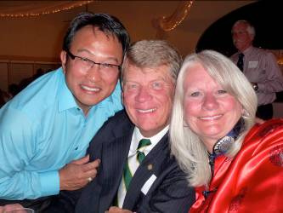
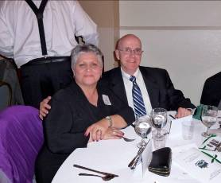

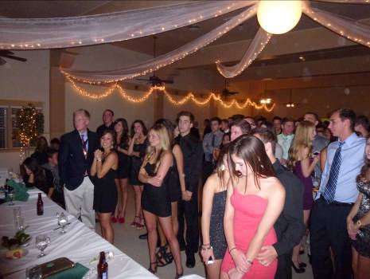

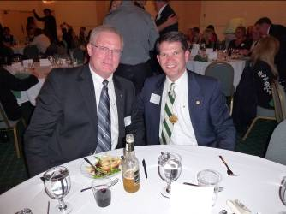
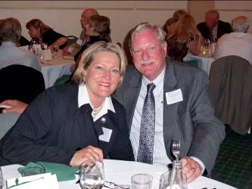

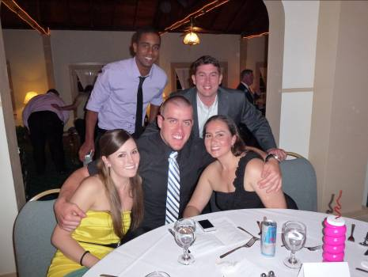

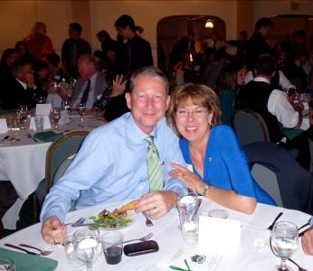
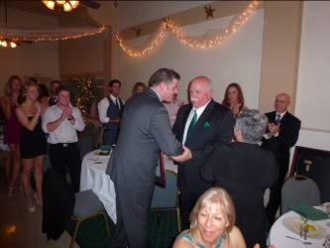

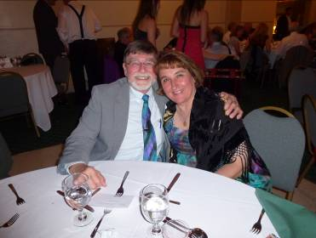
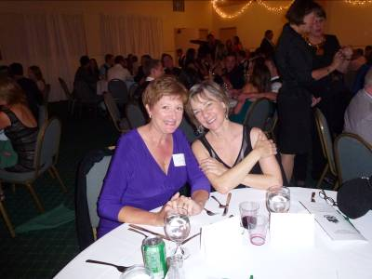
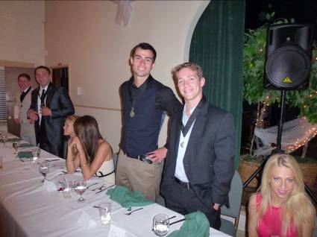

Carnation Ball – Exec Officer Medallion Ceremony:
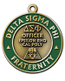
The Alumni Association, on behalf of all our members, returned an important leadership tradition unique to our chapter. For over four decades, until around 2000, our Executive Officers wore medallions suspended from black ribbons about their necks – an emblem of office. These were only worn during formal occasions such as initiation banquets, officer installations, Carnation Ball, etc. The old medallions were worn with extreme pride and were a reminder of each officer’s responsibility to our brotherhood and its ideals. Once a year, at the end of his term of office, each officer would individually pass his medallion to his newly elected counterpart. To begin anew, at Carnation 2012, we returned these unique, one of a kind, emblems of office to our current Executive Board in the manner that was practiced for decades.

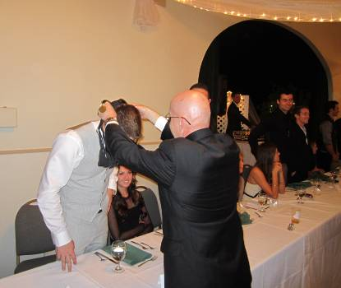
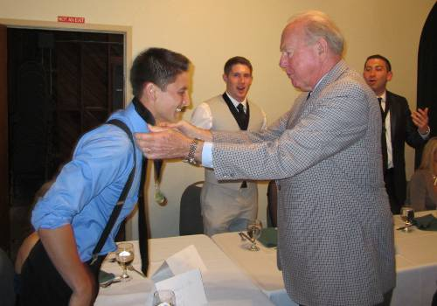
Presenters included three visiting national officers, ACB President Bob “Ace” Veazie, S’76, and Alumni Association President Ray “Mumbles” Calande, W’74. Past Chapter Supervisors John “Si’mon” Kerr, S’58, Bill “Fubar” Bradley, F’62, and Scott “Stub” Morlan, W’71 also presented medallions. Past chapter Presidents Bob “Pele” Ferguson, W’70, and Mike “Snidley” Ivy, S’71, the first two Presidents of “New House” completed the group of presenters. The two photos about are of past Chapter Supervisor John Kerr and current Alumni Association President Ray Calande.

Carnation Ball – Recognition Of Alumni By National:

In a surprise presentation, Executive Director Scott Wiley bestowed national recognition on three Epsilon Rho alumni.

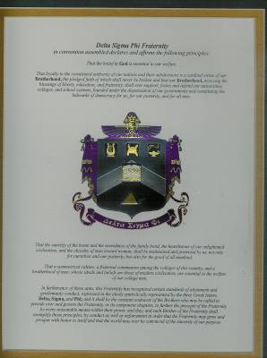
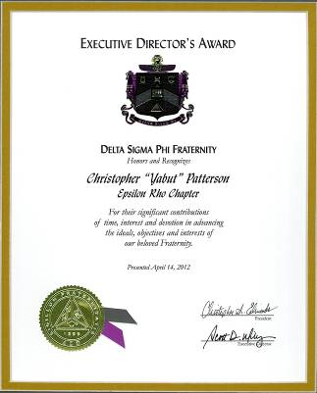
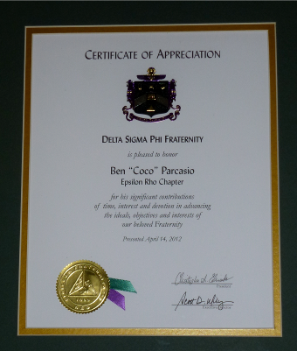

Fraternity Principles Certificate of Appreciation Executive Director’s Award
John “Si’mon” Kerr, S’58 Ben “Coco” Parcasio, S’74 Chris “Yabut” Patterson, W’73

Carnation Ball – Scholarship Presentation:

Six scholarships for a combined total of $4,000 were presented to actives by alumni.

Our ACB President “Ace”, on behalf of ACB, presented four scholarships:
$500 - New Member Scholarship – Matt “Sharp” Aoto, S’11
$500 - New Member Scholarship – Mark “Blue” Pero, F’11
$500 - Kevin Costello Scholarship – Keith “Ogoc” Brosh, F’09
$500 - Kevin Costello Scholarship – Oliver “Broc” Liu, F’09

Our Alumni Association President “Mumbles”, on behalf of Assn. members, presented two scholarships. These are made possible by alumni dues and donations:
$1,000 – Joel Setaro Pimentel Guerrero Scholarship – Nick "Farva" Rimicci, S’10
$1,000 – Working Brother Scholarship – Robert “Kaps” Guerrero

Congratulations to each of our scholarship winners!

Carnation Ball – Individual Alumni Gift:

Thanks to alumnus Carl Cowen, W’56, for his generous gift in support toward the cost of Carnation Ball. Carl sent his best wishes to all of us. He also donated a big screen TV in May for the chapter’s “tube room” - to foster increased group interaction. Thanks Carl for all you’ve done through the years.
The Decision To Build – From Palm To Mustang To California!
By Greg “Chucker” Van Houten, W’70

“Chucker”, Chapter President during transition from the Palm House to the “New House”, remembers the following for us.
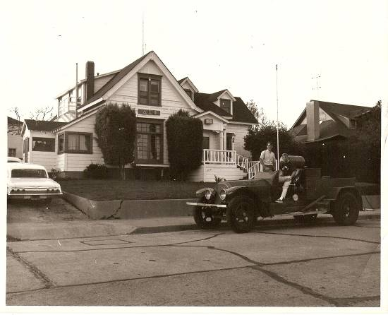
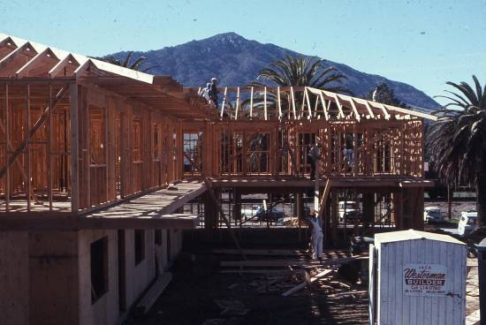
“Leaving Palm House was a controversial proposal at the time. The vote to build a new house was not unanimous, with a large part of the membership wanting to stay at Palm, despite the dramatically increasing rents. However, the younger members felt that the post-war founders and subsequent brothers of Epsilon Rho had given us a gift, in the ownership of the new property, and that we had to fulfill its promise.”

“The design of the California House came about primarily due to the elongated and deep lot. We all wanted to make the house larger, with aspirations to have 100 actives live in, but we had to settle on less. We were governed by a height restriction, maximum coverage/density on the lot itself, and the need for on-site parking. We had dozens of conversations at actives’ meetings about what features and attributes were needed, with specific thought to meals, meetings and ceremonies.”

ACB President’s Report: “Keeping Our Eyes On The Prize”
by Bob “Ace” Veazie, S’76

We as brothers, both alumni and active, will no longer tolerate unacceptable, un-brotherly, personal or group conduct by actives in our chapter. New strategies and policies are being introduced, and actions taken, to build a better brotherhood based on values and character. With your support, we will see the end of many problems. These include financial abuses by some against our chapter and ACB. We are also developing means to end the disrespect that has occurred at some Carnation Balls. We are managing and bringing an end to the alcohol-related problems at our chapter house - including the many risks they present. We are transforming our chapter from one that is average by today’s standards, one which at times demonstrates unacceptable behavior, to the leading fraternity at Cal Poly. Every brother, alumni and active, will be universally proud to be a part of the house we will become.

I’ve only been your ACB President for 15 months but have invested hundreds and hundreds of hours to identify and start resolving problems - by creating strategies to foster change at Epsilon Rho. I’ve seen how 80% of our time is wasted, focused on BS, because we haven’t led well. Let me bring you up-to-date on recent events and share with you the significant changes we are enacting in September. And please hear clearly - I need the help of twenty-seven alumni for one hour a month during the nine-month school year - to call and coach an active live-in brother.

Five years ago, at the request of the growing active membership, ACB agreed to a multi-year lease of an apartment house (MVP) adjacent-to-campus, to house live-outs. DSP has never considered nor run, nor regulated this privately owned facility as an annex, but campus considered it as such. As the result of a party at MVP in early April of this year, and subsequent campus / national discussions, national placed Epsilon Rho on social probation until July 31, 2012. As part of this probation no alcohol was permitted at the chapter house. I am pleased to report that we are now off of probation and on our way to a position of low risk and high standards.

I’ve just returned from another trip to SLO – this time to manage ACB’s hand-over of the MVP property on July 15th, the end of our five-year lease commitment. Part of my mission was to minimize the property owner’s retention of active brothers’ deposits for cleaning. Part of my purpose was to protect ACB from additional end-of-lease charges. Thank God we are finally out of that property. We never foresaw the magnitude of financial risk that MVP presented to DSP. This facility’s rent was $19,000 a month - triple the monthly rent burden / cash flow for our chapter house. These monies were owed a business and not our fraternity, and some of those living there didn’t always pay on time or in full.

ACB is in the process of taking a pin from one of the worst offenders at MVP apartments, a “brother” who won’t pay his last three months rent - $2,100. The chapter paid this for him to Cal West, the apartment owner’s property manager, from their treasury, and the chapter has been unsuccessful at collecting it. Alumni stepped in and have also been unsuccessful. This same individual now accuses me of being responsible for the theft of his drum set from MVP that he claims equals what he owes DSP.

The primary goal of the “MVP project” was to add $100,000 over 5 years to the building fund while providing group housing for a significant number of live-outs. Looking back, we probably broke even financially (no profit) and the sole benefit of MVP was providing more living area where brothers could be together. However, in the last two-plus years, any positive MVP benefit was far outweighed by the liability, headaches, and diversion of attention it created. The way our actives inappropriately used this property for socials almost cost us our charter. No more and never again. We need change.

The following comprehensive strategy will be implemented at our chapter when ACB holds a special weekend meeting there in September. I will be meeting with all twenty-seven live-ins at 244 to discuss who we are as a fraternity and the values and expectations of each other.

We all want the same results from our chapter and its program:
1. Most importantly - creating the Yitbos bond;
2. Improving respect for and appearance of property – make 244 the best and keep it that way;
3. Maintaining our financial integrity to reinvest in 244;
4. Producing better men – developing leadership and a service-orientation.

I am pleased to announce that for the first time in 3 to 4 years our financial position is stronger. We have added $40,000 to savings in the last 15 months. We also invested $20K-25K in the chapter’s landscaping and the house looks really nice. Thanks go to Froggie, Twitch, Zoobie, and the many actives that helped.

I am asking you, our alums, for help. I need 27 of you to coach our 27 live-ins beginning this coming September. This would entail your making a monthly phone call to the young live-in active you are assigned. You will be helping instill the core values of our brotherhood as a “coach”. I see this commitment as requiring only about one hour of your time each month. I will provide you the questions to ask and you can add your own. I believe relationship-building, influence, and personal guidance will have a greater positive impact on our young men than will top-down command-and-control.

We need to manage our core risks:
1. Alcohol and this generation’s periodic practice of binge-drinking;
2. Recruiting the wrong guys and rushing to the wrong standards;
3. Waste and theft - that in the past had reduced our treasury.

Starting in September we will be re-grounding, and putting in place, policies to minimize our risks, improve the quality our chapter’s program, and build the character of our men.

Alcohol Policy:
- Our chapter house will be dry (no alcohol) at all times unless pre-approval is given by ACB for a special event. If ACB gives pre-approval, the chapter must follow national’s alcohol risk-management policies including hiring a qualified third-party present to control and provide alcohol to those of age.
- At least once a month an alumni assigned by ACB will inspect the house against this expectation.
- Failure of Exec officers to enforce this policy will result in a 25% reduction in officer compensation and trigger a 2nd unannounced audit in the same month. Another violation will cause yet another incremental 25% reduction in officer comps.

Financial Policy:
- ACB will no longer lend the chapter money because of mismanagement, waste, and lack of adequate budgeting. (This practice has been out-of-control and tens of thousands of dollars have been wasted)
- The chapter will asses and collect from each member $25 for every $2,000 in accounts receivable that is 60 days delinquent. ($2000 equals $25 per person - no doubt when they all have to pay, they will better self-manage the ongoing problem of lack of financial integrity by some of the members).

Exec Officer Compensation Policy:
- Exec officer compensation will now be based partly on service and partly on performance of duties.
- For each officer receiving compensation, 50% will be based on service.
- For each officer receiving compensation, 25% will be based on the chapter’s financial performance – not having accounts receivable over 60 days past due.
- For each officer receiving compensation, 25% will be based on adherence to the alcohol policy. An additional, second 25% will be docked for failing a second ACB walkabouts in one month.

Brothers, we are here to build better men. We are here to help them do a better job of leading our fraternity. We are here to help them see with a heart of service. It is time we refocus on helping our men to learn and grow and lead with our core values.

To make these changes happen, we must apply our energy where it does the most good. For this reason, I have invited author Jim Collins to San Luis Obispo to promote leadership and values in our young men. We’ve not finalized the plans yet, but he will join us to talk about organizational effectiveness, leadership, and how to manage-by-values. This is what we need to return to our chapter, because they must practice daily decision-making and manage in the absence of out-of-town alumni officers.

The year ahead will return Epsilon Rho, finally, to a chapter you will be proud of. We have a good group of guys in leadership to build with. With the right management, leadership, and alumni coaching, DSP at Cal Poly will again return to the best chapter in the nation - and you will be proud to be a brother.

Please email me at followthearrow@hotmail.com if you wish to help by being a coach to a live-in active this coming school year. This program is an essential part of our overall effort to create the changes which are needed.

Editor’s note: just prior to publication, ACB announced a new measure to prevent a future “MVP Syndrome” and assist Exec in enforcing the new alcohol policy. A permanent fence will be built, without gate, in August between two properties currently open to each other with a semi-common backyard - the DSP-alumnus-owned, and rented to actives, Hathaway property, and the chapter house property.

Alumni Association - “How We Serve Alums And Chapter”
by Alum. Assn. Officers

Your Alumni Association Promotes Our Bond And Brotherhood

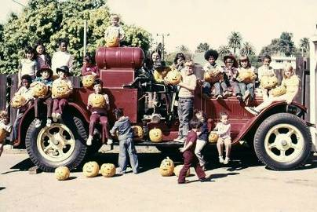
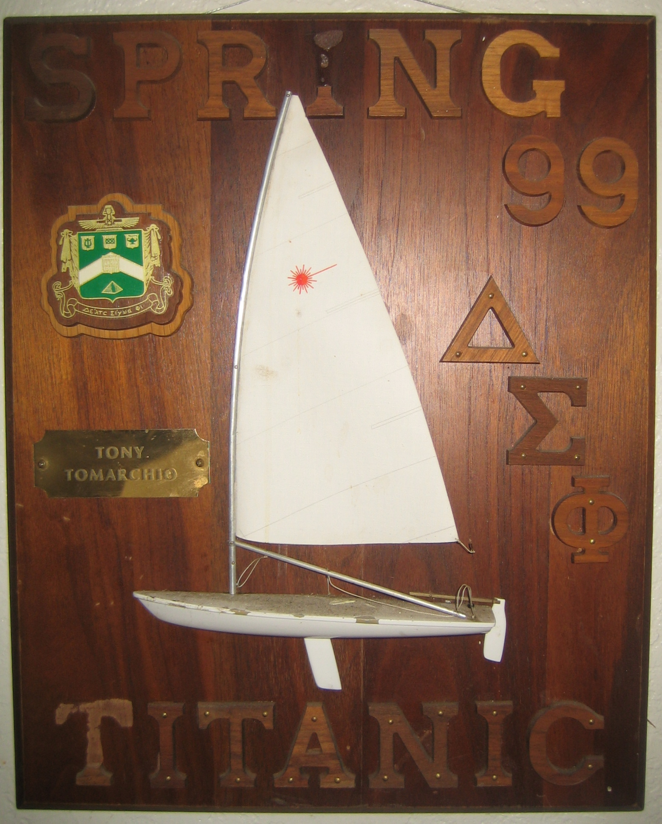

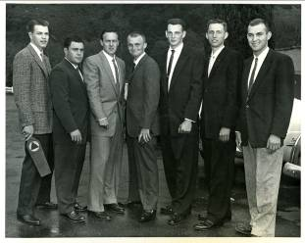

We Help Reunions Preserve DSP History Encourage Philanthropy Share Paddles
(1958 Exec Board) (1974 Pumpkin Carve) (Spring 1999 Pledge Class)
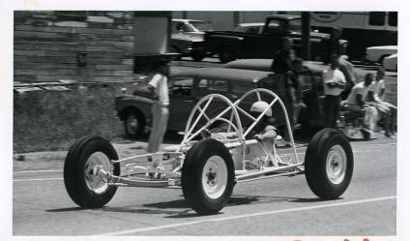
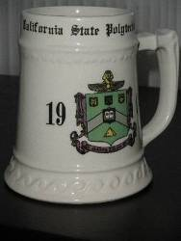

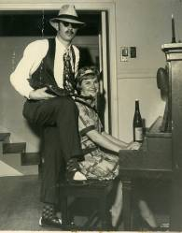
We Promote DSP Ideals We Show Continuity We Tell About Our Past What’s This?
And Brotherhood (1962 Al Capone) (1965 DSP Tub Racer Wins at GW)

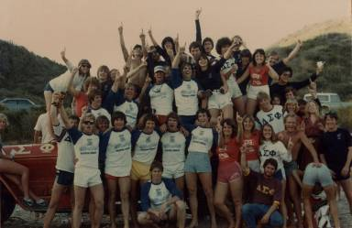
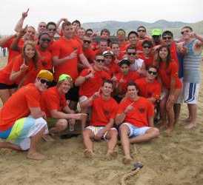
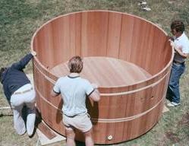
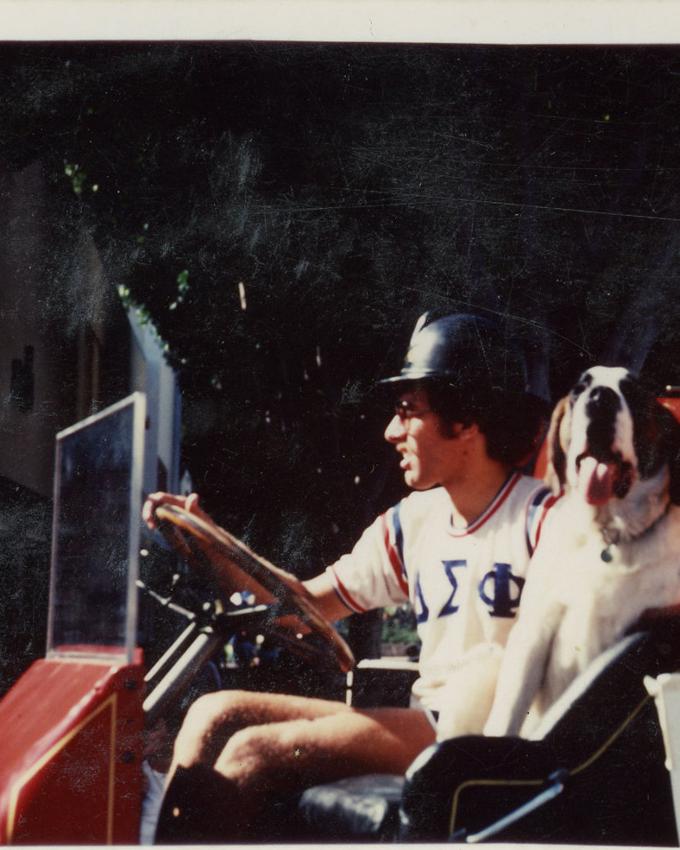

We Show Teamwork Then And Teamwork Now Improving Our House Traditions
(1981 GW Champs) (2010 GW Champs) (1976 Hot Tub) (Ralph, Barney, or Cuesta)
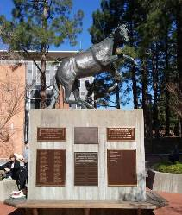
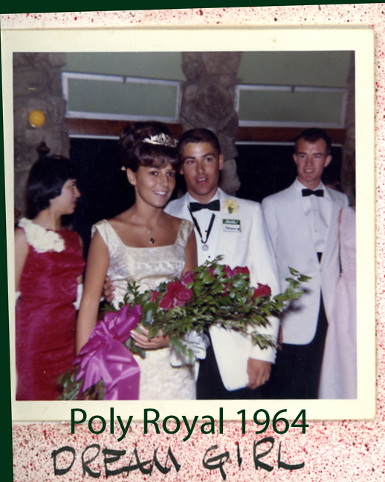
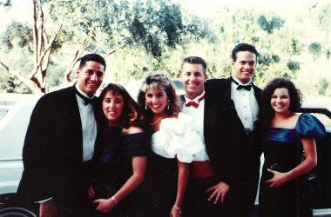
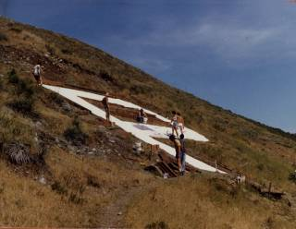

Show Campus Involvement Sculpture Dream Girl Tradition Carnation Ball Formal
(1957 DSP Builds Poly P) (1982 – DSP Donates) (1964) (1991)

Your Alumni Association Designs Chapter Gifts
To Teach Our History, Show Our Values, & Encourage Engineered Leadership

This year our gift focused on leadership. In the name of our alumni, we researched, designed, had cast, and gave Exec officers the “emblem of office some of us wore, and all of us remember, from our chapter days. Each officer will convey his medallion to the next elected officer.

Last year our gift focused on creating a “teaching tool” about our unique, three-house, history. We gave a custom-developed set of house pictures – each with its unique history.
Our actives are very proud of these and prominently display them at the chapter house.
They will continue to instruct our new brothers for many years to come.

676 Monterey Street 1134 Palm Street 244 California Blvd.
1951 – 1953 1954 – 1971 1972 - Present
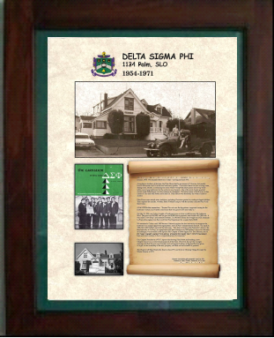
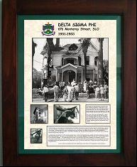
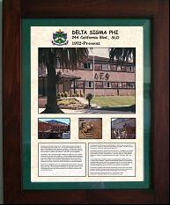

Besides serving our alumni by working for a better chapter, we offer alums direct services. Besides providing alumni with newsletters, we’ve built and maintain our own alumni web site at http://www.SLOYITBOSALUMS.com. On this site you will find alumni news, reunion notices, photo album, past newsletters, our history, expanded news of the chapter, and an alumni directory.

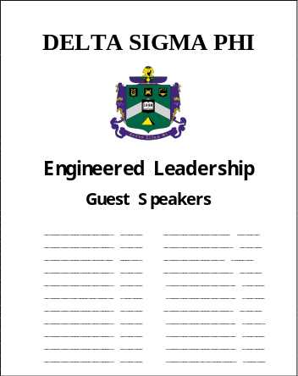
Before these gifts, we reinstated the EL Speakers Board and program. Using old photos, we duplicated the “EL Board” and returned this tradition to our chapter. It had been lost in the late 1990’s. The most recent, notable, “speaker” and signor of the board was Cal Poly’s President Armstrong in February 2012.

Unlike ACB which receives rents from the chapter house, your all-volunteer Alumni Association is 100% dependant on alumni giving to cover our costs.

You can help us continue our work for alums and chapter by becoming an Alumni Association member. Please send in your 2012 dues of $20 and a donation you‘re comfortable with. We maintain what we’ve built with dues – and give scholarships and instructive gifts with your donations. You have my word that every cent goes to DSP.

Your Brotherhood-from-afar makes our work for DSP possible.

Please make your check payable to DSP EP Alumni Assn. and mail it to Brother Ray Calande (“Mumbles”, W’74) at 1384 Rue Avati, San Jose, CA 95131-2547.

Y.I.T.B.O.S. !

